Phuong’s Story

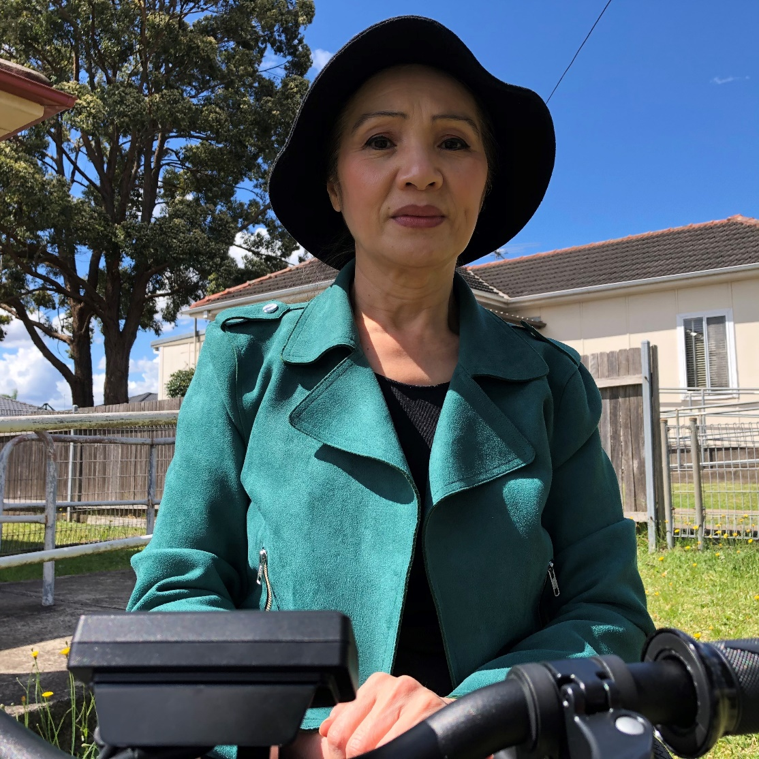
Hello everybody, my name is Phuong.

I am going to tell you about the journey that helped me become more confident and empowered.

I love, cherish and value myself and have striven forward to change my life into a more active and happy one since I engaged in Diversity Disability Association (DDA), a peer led organisation providing peer support.

More than three years ago, on an unfortunate night, I had a severe fall. Since then I have been in a wheelchair, there was no other choice for me. I was feeling lost and suffering emotionally, confining my life within the four white walls of my house, which for me was like a prison because it was located in a quiet corner of a secluded street. My parents, who were then in their 90s, and my younger brother had to bring me items and ready-made food, but only once a week. Then my mobile phone fell on the bathroom floor and was not working. I was not able to connect with the outside world for one week. There was no television nor landline telephone. All that I was experiencing was just fear and fear. I had never expected that I could fall into that situation.

For one year after my fall, I lived in melancholy, idleness, sadness, crying and fear of everything. I was fearful that my parents could die anytime, that I had to live like this forever. At that time, I had to depend on the care provided by my elderly parents and my younger brother. I could see that my Mum was very sad and quiet.

Then one day, I suddenly realised that my parents are too old to take care of me forever. They deserved a rest. They themselves were relying on walking sticks due to their old age,
and my younger brother had to care for his own family. I was awakened by that insight. I tried my best to overcome the language barrier, made phone calls to get relevant information and applied for NDIS funding for support persons and also for wider social connections.

While waiting for my application to be processed, I accessed an information network in order to gain knowledge and relieve stress and boredom. About one year later, my niece came to help me and in the same year, I was introduced to DDA, an organisation supporting the disability community. Since then, I have engaged in DDA activities with other peers. We share experiences, inspire and provide support to each other.
I join in DDA ‘s weekly activities, including different group meetings and peer support training courses. Then came the rolling out of Circles Widen, a new pilot project undertaken by DDA. I am lucky to participate in this project and have opportunities to create a Circle of support for myself. This involved establishing and building up the foundations for a well-managed model of support.

Firstly, there must be a network of close family relatives or friends or people who have some connections already, who know each other well. They must be trustworthy and when invited into the Circle, everybody works together with the spirit of volunteerism and unity. It is all the better if we can find several people who have skills in different areas to support the person with disability.

Secondly, building self-confidence is very important in that it will help with social interaction skills through a safe information network. Participation in group activities will help widen our vision.

Thirdly, self-awareness is essential in that we have to deal with whatever happens to us. Life is full of changes and we have to adapt to changes positively in order to achieve self-development.

I invited four people who care about me, including my siblings, close friends and kind hearted volunteers to support my life and meet my needs. Thanks to all these connections, I have been able to live more independently and problems have been addressed quickly. These people are my companions and supporters, each of them has their own duties and responsibilities.

We hold monthly or ad hoc meetings to discuss issues related to my needs. Thanks to that, I can look forward to achieving my bigger dreams. For example, if I want to buy a new car, there will be plenty of sources of information about car related makes, models, sizes, advantages and disadvantages. Everybody makes sure I can make the best informed choice.
If I want to go shopping, or eat at a restaurant, they will be the ones who provide information whereas I am the one who makes the decision. My brothers often discuss up-to -date health information with me, and I am the expert who knows what to choose.

Now I can see that my parents can enjoy peace of mind because I have settled my life and get support from people around me. I am very thankful to everybody for all the opportunities I have. Thank you all for teaching me how to fish so that I can feed myself.

Now the Circles Widen project has a team of professional consultants who work together to provide support to people with disability who want to have a Circle of Support for themselves. I have decided to introduce Circle Widens to Culturally and Linguistically Diverse (CALD) communities. The knowledge and training I have, together with the benefits I am receiving from my own Circle will be utilised to support people in need.

I strongly encourage people with disability in the community to be in control of their life and to consider creating a Circle of Support for themselves. I would like to share with everybody the benefits, which include enhancing the values of living independently, leading to the opportunity of becoming the real master of your life. A Circle can boost your social skills and help you in achieving the dreams and goals you are longing for. You will be surrounded with happiness.

I am a facilitator, working side by side with the consultants of the project, as we work to connect all sources of support together. We also benefit from the language services of a very friendly Vietnamese interpreter.

Thank you and all the best
Phuong
August, 2021

